Bottle Riparian Corridor Instructions
Description:
The Bottle Riparian Corridor is used to model different riparian conditions to teach about the importance of riparian zone. The Bottle Riparian Corridor is made of two parts: 1. The Body and 2. The Rainfall Lid. The Body holds the different materials to demonstrate conditions, such as gravel, soil, leaves…etc…It can also be used in water filter activities where students can build their own water filters. The Rainfall Lid is used to manage the flow rate of water to help minimize error in activities while modeling a rainstorm. It fits like a bowl into the large, open end of the Body of the Bottle Riparian Corridor.

Materials Needed:
- 2-Liter Bottle
- Cheesecloth or Coffee Filter
- Rubber Bands
- Permanent Marker
- Scissors
- Boxcutter
- Electric Drill OR Matches, Iron Nail, and Candle

Step-by-Step Instructions:
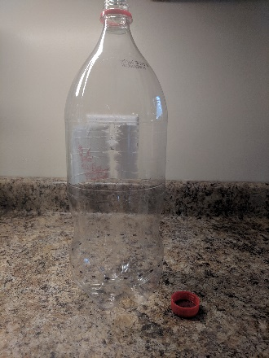
- Take the 2-Liter Bottle. After cleaning it, remove the label and lid.

- Locate the seam where the bottom of the bottle connects to the body of the bottle as shown below.

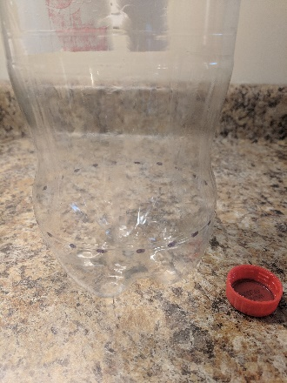
Seam

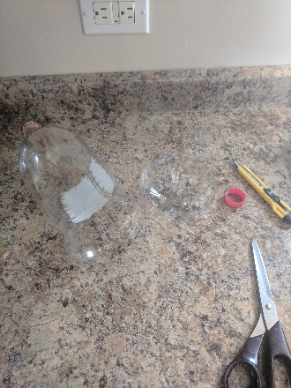
- Use the boxcutter to carefully remove the bottom of the bottle by cutting along the bottle seam. You can also start cutting with a boxcutter, and switch to scissors. It may be helpful to mark the seam using a marker first.

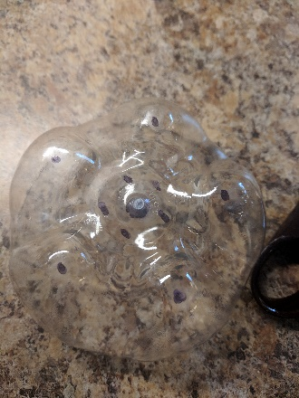
- Take the bottom of the bottle, now removed, and mark a small dot in the exact center of the bottle’s bottom, then five or six evenly spaced dots around the center dot, and then a dot on each center of the small mounds of the bottom.

- Using either a drill or heated nail, poke a hole through each marked dot in the bottom. An 8mm drill bit will be a good size. This will create the “Rainfall Lid”.

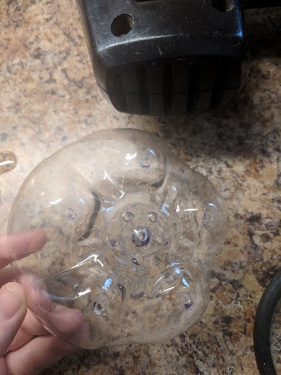
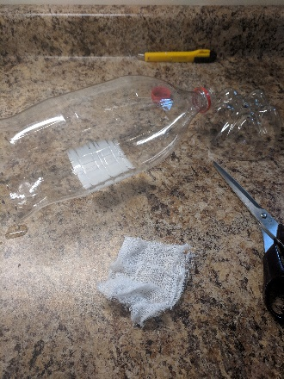
- Take the other part of the bottle and measure enough cheesecloth/coffee filter to cover the mouth of the bottle with some overlapping onto the neck of the bottle and cut off a square.

- Use one or two rubber bands to attach the cheesecloth/coffee filter to the mouth of the bottle. This is the “Body”.
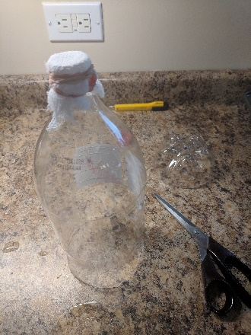
- Fit the Rainfall Lid into the large, open end of the Body. Make a small mark on the Body of the setup where the bottom of the Rainfall Lid is. This will demonstrate the initial distance of the “rain” with the mouth of the Body marking the final distance.

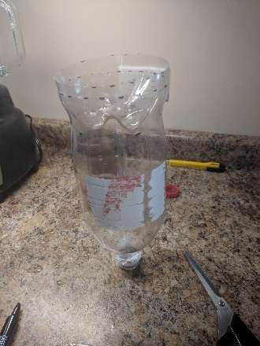
Initial Distance Marks
- Repeat the steps to make as many more Bottle Riparian Corridors as necessary. One Bottle Riparian Corridor is suitable for groups of 2 to 4.

